- Practical command

- ipconfig/all

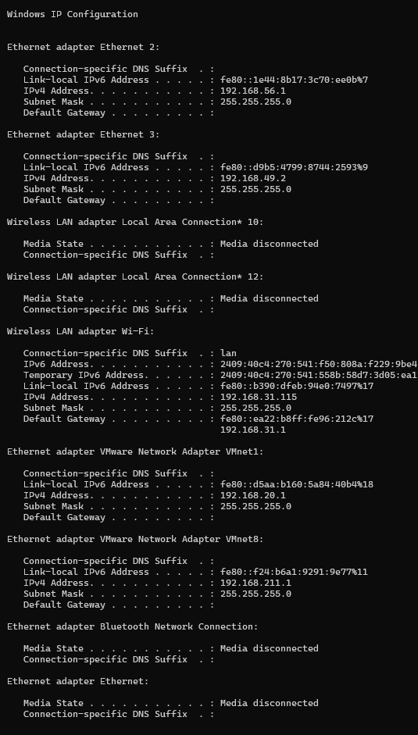

- nslookup google.com
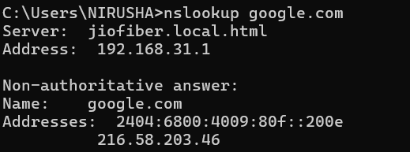
- ping google.com
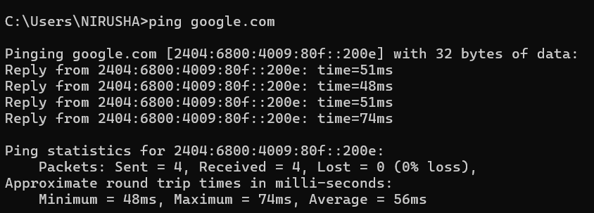

1. What IP address did DNS return for Google?
A.It returns 2404:6800:4009:80f::200e216.58.203.46 as IP address of google .
It returns both IPv6(2404:6800:4009:80f) and IPv4(200e216.58.203.46) address
2. Was the ping successful?
A.Yes , It was successful
3. Why is DNS important before communication begins?
A.It is important because the domain is a high level language which the device can’t understand so it needs an IP address which will be easily understandable to the device .

